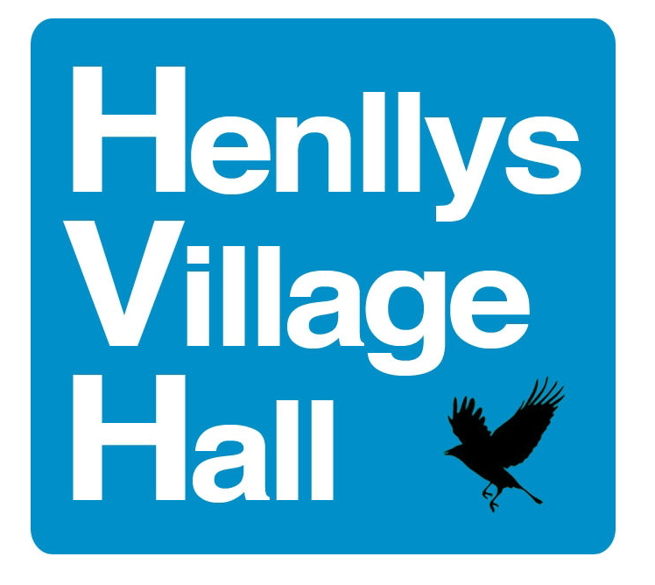  Registered Charity  Number 500183 | HENLLYS VILLAGE HALL  REGULAR CLASSES/MEETINGS
DAY | MAIN HALL
MONDAYS | 9:15am – 1:15pm TOTS PLAY  3:30pm – 5:30pm TAI KWONDO  6:00pm – 7:00pm ZUMBA  7:00pm– 8:00pm LBTS
TUESDAYS | 6:30pm – 7:30pm BODY WEIGHT CIRCUIT CLASS
WEDNESDAYS | 9:45am – 11:00am YOGA  3:30pm – 5:30pm TINY TOES BALLET  7:00pm – 9:00pm AMATEUR RADIO CLUB
THURSDAY | 9:30am – 10:30am PILATES  5:30pm – 6:30pm. PILATES AND YOGA
FRIDAYS | 9:30am – 12noon TINY TOES BALLET
SATURDAYS | 9:00 am – 1:30pm. DANCE CLASSES
SUNDAYS
HENLLYS VILLAGE HALL
REGULAR CLASSES/MEETINGS

DAY | MEETING ROOM
MONDAYS | 9:00am – 3:00pm CB TRAINING  7:00pm – 9:00pm HENLLYS VILLAGE HALL TRUSTEE COMMITTEE  (3rd Monday of alternate month)  6:00pm – 8:00pm HENLLYS COMMUNITY COUNCIL MEETING  (2nd Monday of each month)
TUESDAYS | 10:00am – 12noon WILLOWLANE DESIGNS  7:00pm – 9:00pm CWMBRAN ALLOTMENTS SOCIETY MEETING*
WEDNESDAYS | 10:00am – 12 NOON HENLLYS LADIES COFFEE MORNING (FULL)  1:00PM – 4:00PM VIRGO CARE HOMES LTD (ALTERNATE WEDS)
THURSDAYS | 10:00am- 12noon HENLLYS QUILTERS  7:00pm – 9:00pm KNIT, NATTER & CRAFTS  (alternate Thursdays)
FRIDAYS | Check availability with Brian Morgan Hall Supervisor
SATURDAYS | 11:15am – 12:15pm HENLLYS LABOUR WARD COUNCILLORS’ . MONTHLY SURGERY (First Saturday of each month)
SUNDAYS

*Not every week

